**Migratory situation in January – Western Mediterranean accounts for half of detections**

2019-02-13

In the first month of 2019, the number of detections of illegal border crossings on Europe’s main migratory routes fell by a third compared to December to 6 760. The total was a fifth less than in January 2018 because of the lower number of migrants taking the Central Mediterranean route.

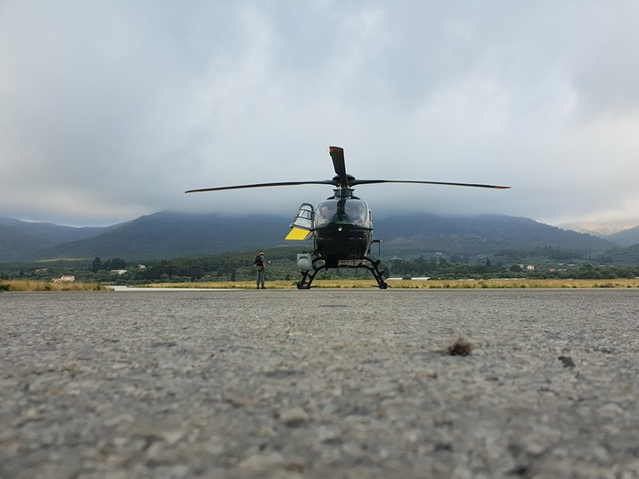

**Western Mediterranean**  
The Western Mediterranean route remained under the most intensive migratory pressure, accounting for more than half of the irregular migrants reaching Europe in January. In the first month of the year, the number of detections on this route fell 18% from the previous month to nearly 3 780. However, this is more than double the figure from January 2018.

Nationals of Guinea and Morocco accounted for the largest number of detected migrants on this route.

**Eastern Mediterranean**  
The number of migrants taking the Eastern Mediterranean route in January fell 44% from the previous month to close to 2 540, although the figure was 10% higher than a year ago.

Nationals of Afghanistan, who mainly arrived by sea, and Turkey, who mostly crossed the land border, accounted for more than half of the detections in this region.

**Central Mediterranean**  
The Central Mediterranean route saw the biggest drop in the number of irregular migrants. There were nearly 150 migrants detected on this route, a fall of 73% compared to December and 96% compared to January 2018.

Bangladeshis and Tunisians were the most represented nationalities reaching Italy.

**Western Balkans**  
There were more than 300 detections of illegal border crossings recorded on this route in January, half the number from the previous month and 42% less than a year ago.

Nationals of Afghanistan accounted for the largest share of migrants detected on this route.

*Note: The data presented in this statement refer to the number of detections of irregular border-crossing at the external borders of the European Union. The same person may attempt to cross the border several times in different locations at the external border.*